**India’s Agricultural Crop Production Analysis(1997-2021)**

# INTRODUCTION

* 1. **Overview**

This report delves into the captivating realm of India's agricultural cultivation, providing a comprehensive visual exploration of key aspects and trends in the agricultural sector. Through the visual representations, readers can gain valuable insights into crop production, seasonal variations, regional distribution, and overall production trends. These visualizations enable intuitive analysis, allowing stakeholders to uncover patterns, identify areas of growth or concern, and make data-driven decisions.

By harnessing the power of Tableau, this report not only presents the data in a visually appealing manner but also provides an interactive experience for readers to explore the intricacies of India's agricultural cultivation. To Extract the Insights from the data and put the data in the form of visualizations, Dashboards and Story we employed Tableau tool.

* 1. Purpose

This project highlights the crop production in India for a particular period. The Agricultural Crop production during the year 1997-2021 has been analyzed. Excellent outputs regarding the ……………….

2. **Problem Definition & Design Thinking**

1.3 Empathy Map

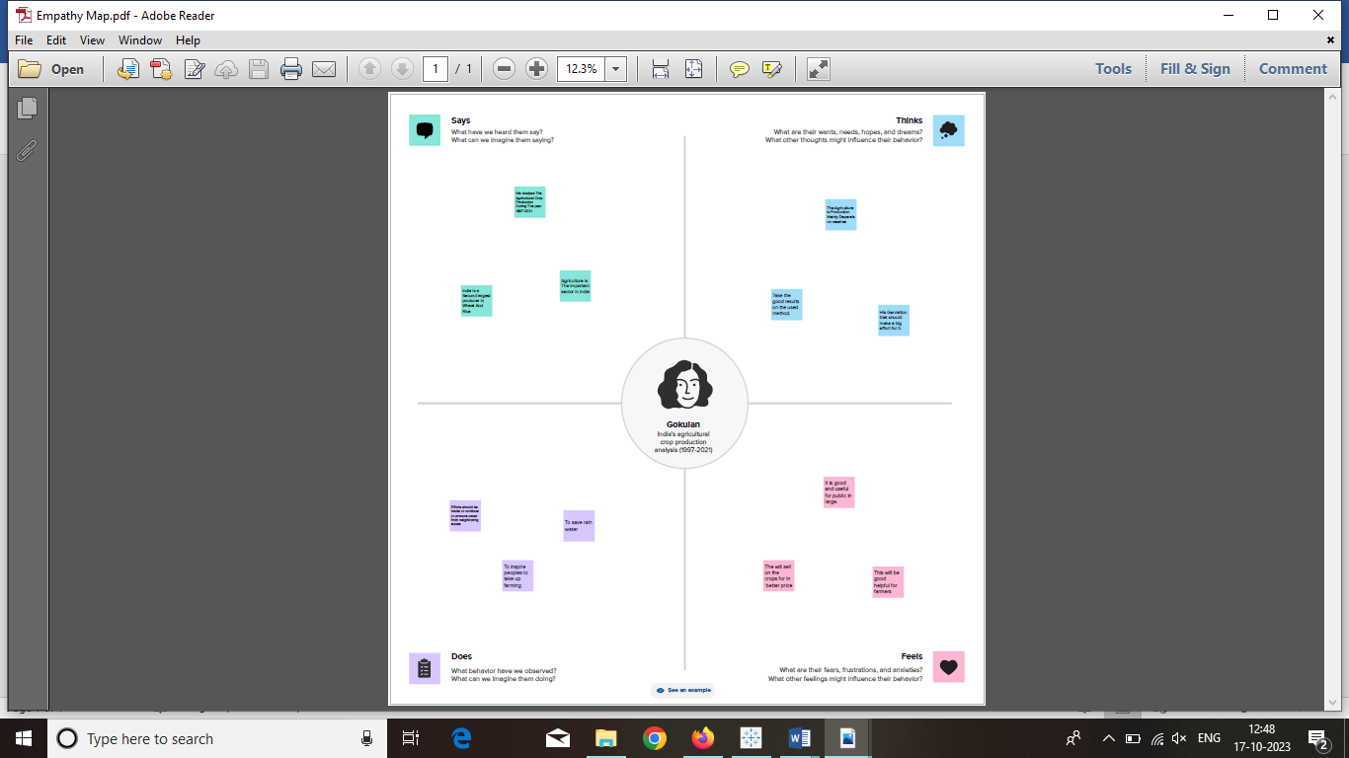

1.4 Ideation & Brainstorming Map

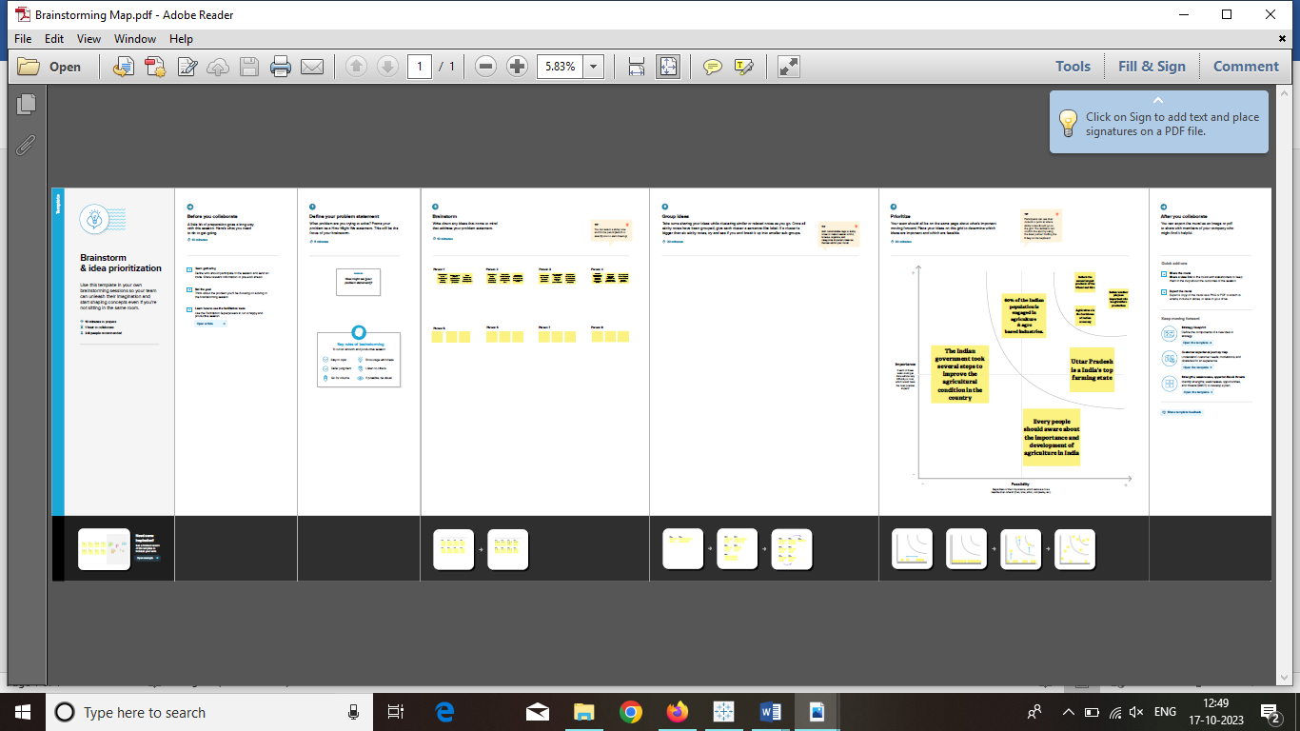

**State Wise Agriculture Land Map**

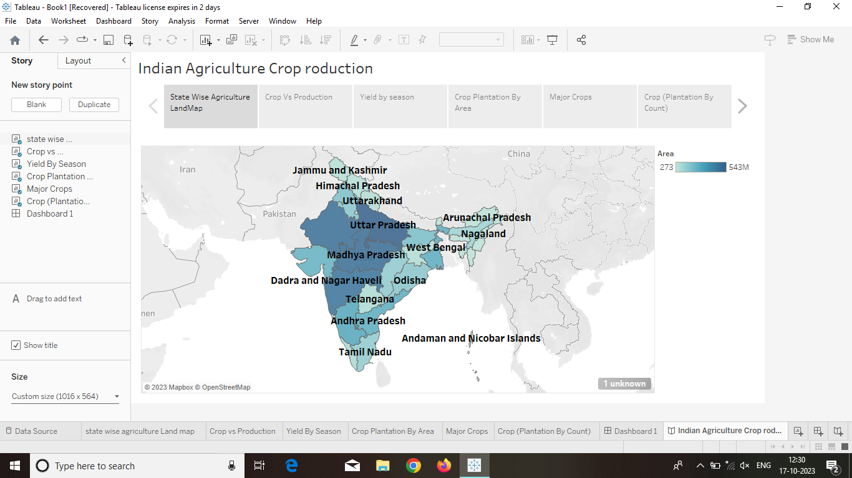

**Crop vs Production**

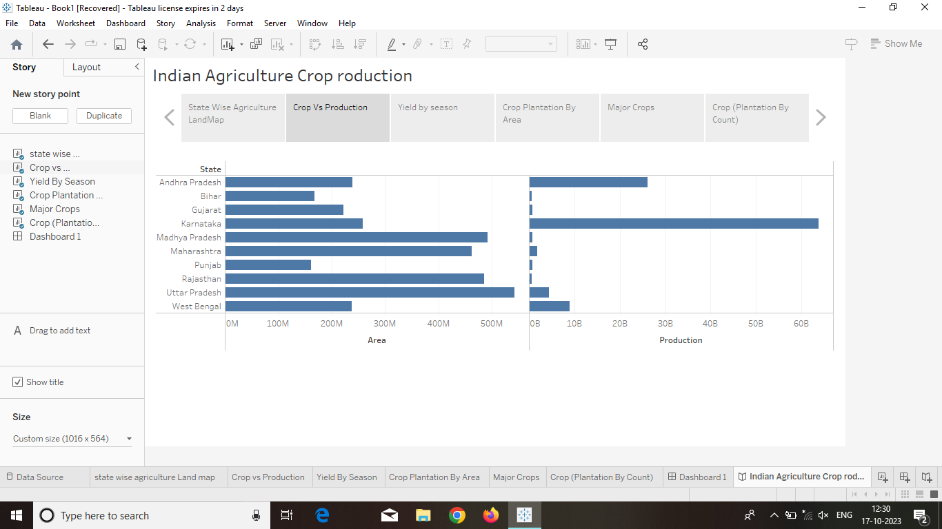

**YIELD BY SEASON**

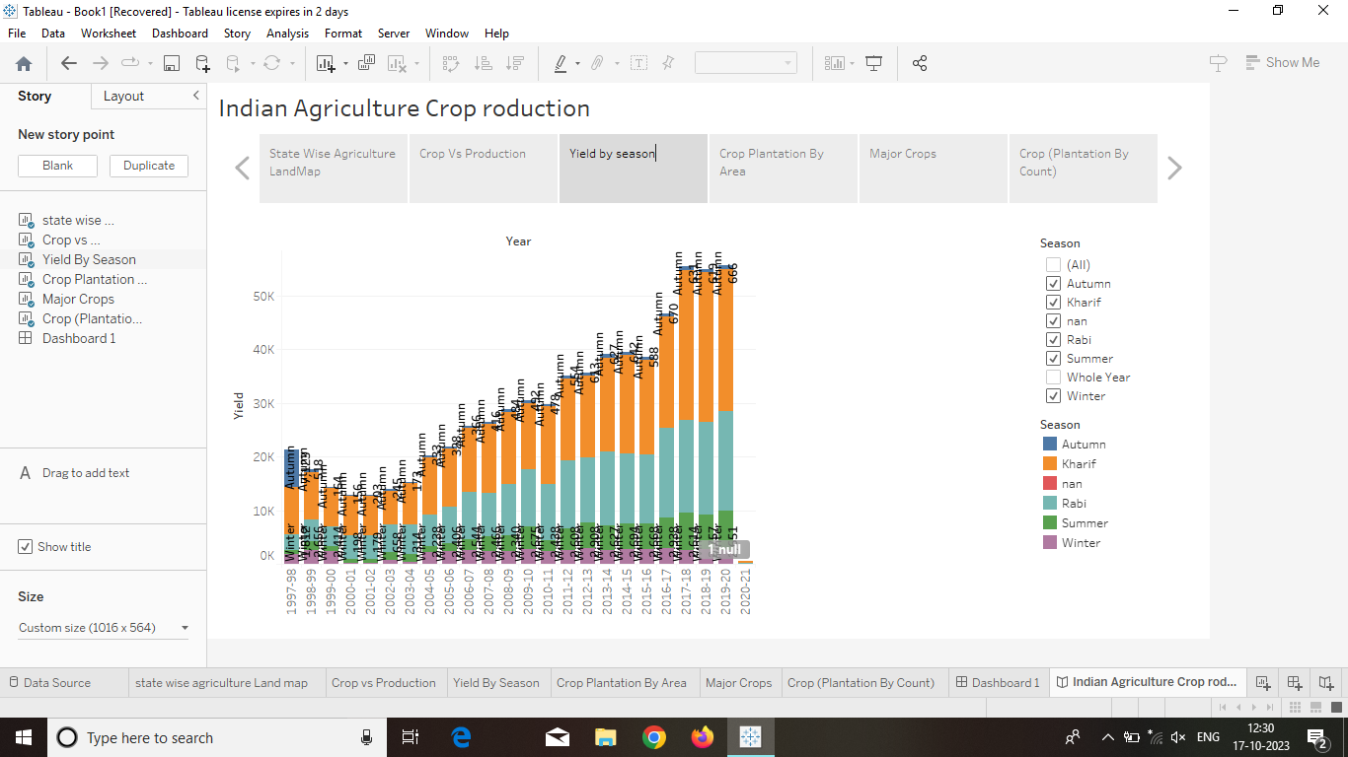

**Crop Plantation By Area**

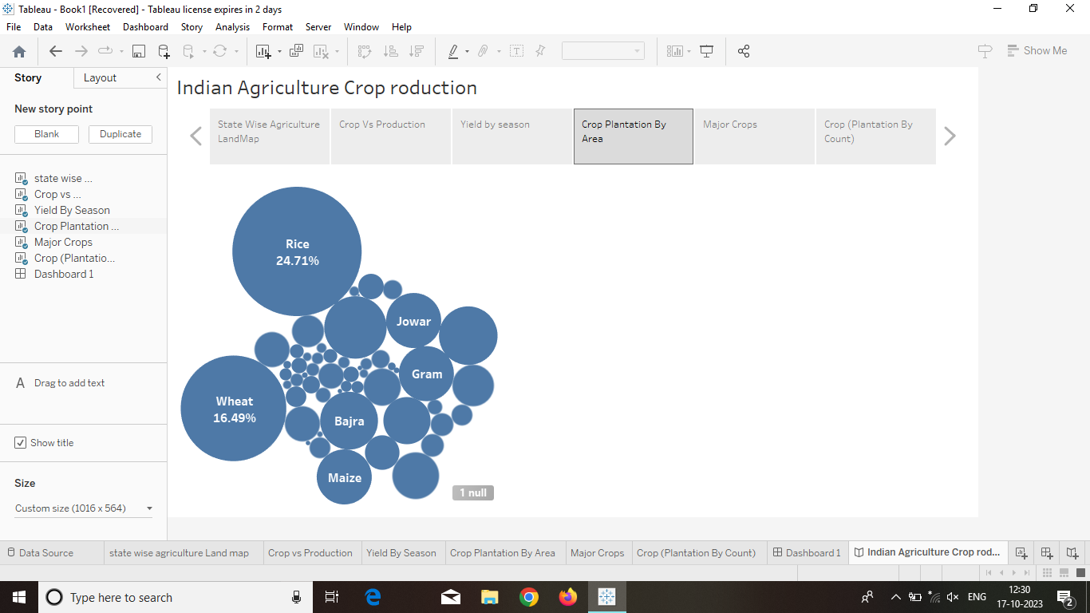

**MAJOR CROPS**

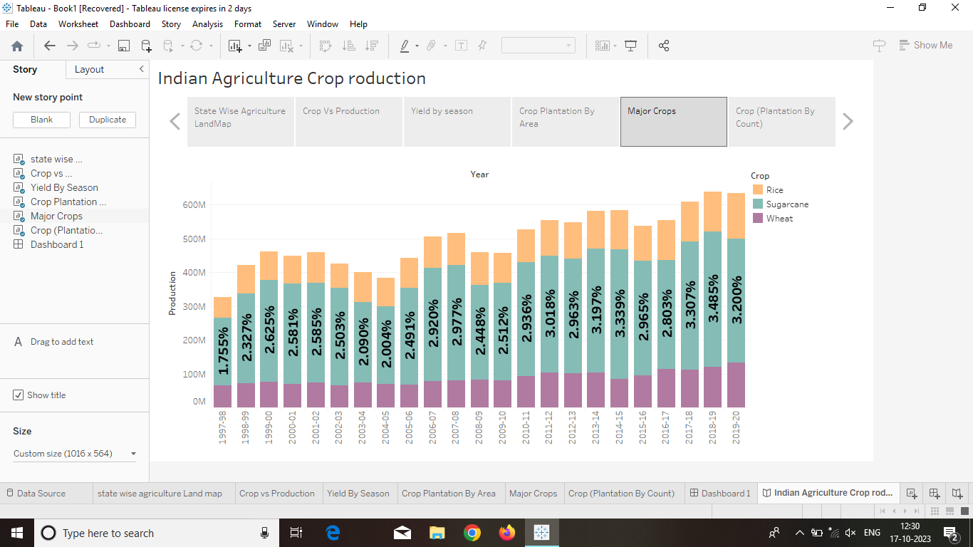

**CROP (PLANTATION BY COUNT)**

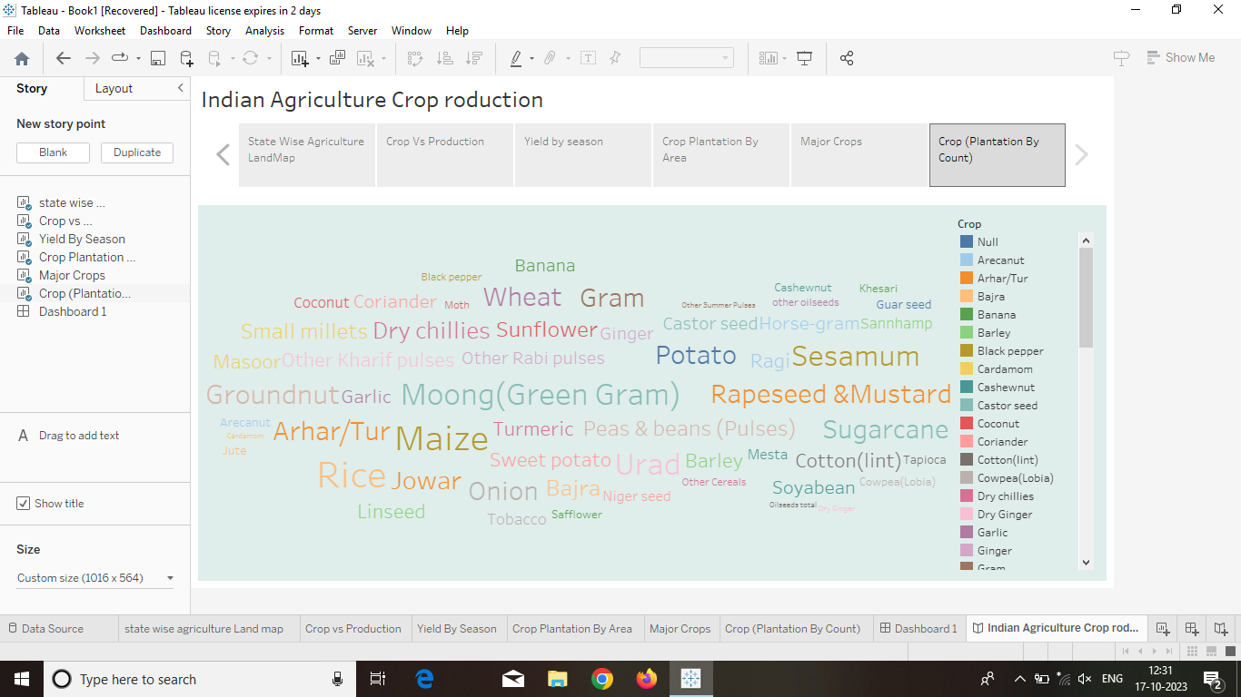

**4. ADVANTAGES & DISADVANTAGES**

\***Advantage**:

* *Controllable food supply. You might have droughts or floods, but if you’re growing the crops and breeding them to be hardier, you have a better chance of not starving.

*Especially if you grow grain, you can create a food surplus, which makes cities possible and also the specialization of labour. Like, in the days before agriculture, everybody’s job was foraging, and it took about a thousand calories of work to create a thousand calories of food, and it was impossible to create large population centres.

*Agriculture can be practised all over the world, although in some cases it takes extensive manipulation of the environment, […] irrigation, controlled flooding, terracing, that kind of thing

*if you have a surplus, agriculture can support people not directly involved in the production of food. Like, for instance, tradespeople, who can devote their lives to better farming equipment, which in turn makes it easier to produce more food more efficiently, which in time makes it possible for a corporation to turn a profit on this ninety-nine cent double cheeseburger. […]

*Some would say that large and complex agricultural communities that can support cities and eventually inexpensive meat sandwiches are not necessarily beneficial to the planet or even to its human inhabitants. […]

\***Disadvantage**

: * In order to keep feeding people as the population grows you have to radically change the environment of the planet

*Farming is hard. So hard, in fact, that one is tempted to claim ownership over other humans and then have them till the land on your behalf, which is the kind of non-ideal social order that tends to be associated with agricultural communities.’

* The excessive use of chemicals by the help of machines reduces the fertility of the land.

Lack of practical knowledge the farmers cant handle the machines properly

* While the cost of maintenance is very high.

Overuse of machines may lead to environmental damage.

It is efficient but has many side effects and drawbacks.

* Furthermore, Driverless agriculture machine is a liability to access the technology.

Improve the scouting programes.

The robotic machine could not change their culture, we have to set their programme manually.

Most of the farmers are illiterates so they are unable to use the modern machines.

**5. APPLICATIONS**

Indian uses comprise about 30% of the total volume of the global future phone market making it the second largest in the specified field.

In 2015 india add 720 million mobile phone usesers out of wich 320 million were rural mobile phone usesers.

This estimate also included 50 million smart phone usesers with acces to internet.

**6. CONCLUSION**

India”s agreeculture sector still very important to the Indian economy although its share of the economic as degcresed ovr the past 50 years.

India as made significant advances in agreecultural production in recent decades,including the instroduction of high -yield shield varieties increased uses of fertilisers and improved water management systems.

**7. FUTURE SCOPE**

Due to globalization, increase in house old incomes and health consciousness the demand for fruits and vegelables, diary products fish and meet its going to increase in future.